Chapter 10, Problem 83.

Use PSpice to find v_{o}(t) in the circuit if Fig. 10.125. Let i_{s} = 2cos(10³t) A.
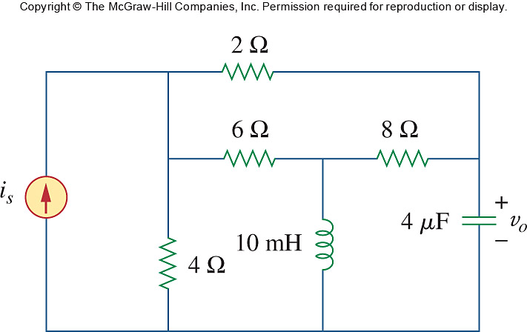

Figure 10.125
For Prob. 10.83.

